This text is meant purely as a working document and has no legal effect. The Union's institutions do not assume any liability for its contents. The authentic versions of the relevant acts, including their preambles, are those published in the Official Journal of the European Union and available in EUR-Lex.

ANNEX III

METHOD OF MEASUREMENT OF AIRBORNE NOISE EMITTED BY EQUIPMENT FOR USE OUTDOORS
Scope
This Annex lays down the methods of measurement of airborne noise that shall be used for the determination of the sound power levels of equipment covered by this Directive with a view to the conformity assessment procedures of this Directive.

Part A of this Annex for each type of equipment referred to in Article 2(1) lays down

- basic noise emission standard

- general supplements to the basic noise emission standard

for measuring the sound pressure level on a measurement surface enveloping the source and for calculating the sound power level produced by the source.

Part B of this Annex for each type of equipment referred to in Article 2(1) lays down

- a reference to a standard including the noise test code for the equipment category

if there is no specific noise test code available for an equipment category, Part B will lay down the operating conditions to be applied together with the basic noise emission standard in Part A, including

  - the test area

  - the value of the constant K_{2A}
  - the shape of the measurement surface

  - the number and position of microphones to be used

  - requirements relating to mounting of the equipment

  - a method to calculate the resulting sound power levels in the event that several tests with different operating conditions are to be used

  - further information.

When testing specific types of equipment, the manufacturer or his authorised representative in the Community may in general apply the basic noise emission standard of Part A and the specific noise test code or operating conditions of Part B as corresponds for the specific type of equipment. In the event of a dispute, however, the recommended noise test code laid down in Part B has to be used.

PART A

BASIC NOISE EMISSION STANDARD
For the determination of the sound power level of equipment for use outdoors as defined by Article 2(1) the basic noise emission standard
EN ISO 3744:2010

may generally be used subject to the following general supplements:

Measurement uncertainty
Measurement uncertainties are not taken into account in the framework of conformity assessment procedures in the design phase.

Operation of source during test
  - Fan speed
If the engine of the equipment or its hydraulic system is fitted with (a) fans(s) it (they) must operate during the test. The fan speed is, in accordance with one of the following conditions, stated and set by the manufacturer of the equipment and must appear in the test report, this speed being used in further measurements. Reversible mode must be avoided during tests.

    - F a n d r i v e d i r e c t l y c o n n e c t e d t o t h e e n g i n e

If the fan drive is directly connected to the engine and/or hydraulic equipment (e.g. by belt drive) it must operate during the test.

    - F a n d r i v e w i t h s e v e r a l d i s t i n c t s p e e d s

If the fan can work at several distinct speeds the test shall be carried out either

      - at its maximum working speed, or

      - in a first test with the fan set at zero speed and in a second test the fan set at maximum speed. The resulting sound pressure level L_{pA} shall then be calculated by combining both test results using the following equation:

L pA ¼ 10 lg f0,3 Ü 100,1 LpA ;0%þ0,7 Ü 100,1 LpA ;100% g

where:

L^{pA,0} % is the sound pressure level determined with the fan set at zero speed

L^{pA,100} % is the sound pressure level determined with the fan set at maximum speed.

    - F a n d r i v e w i t h c o n t i n u o u s v a r i a b l e s p e e d

If the fan can work at continuous variable speed, the test shall be carried out either according to 2.1(b) or with the fan speed set by the manufacturer at no less than 70 % of the maximum speed.

Visco-static fans, which are automatically regulated by the engine temperature, shall be considered to work at continuous variable speed irrespective of the origin of the control.

    - If the machine is equipped with more than one fan, all fans shall run at either the conditions specified in a) or b) or c).

The manufacturer installing a variable speed fan as defined in paragraphs 2.1(b) and 2.1(c) shall indicate in the technical documentation the relationship between fan speed, ambient temperature and operating load.
In particular, the technical documentation shall include:
― description of fan drive type and number of fan speeds;
― maximum fan speed, minimum fan speed;
― explanation of the cooling system fan speed control logic (what are control inputs and resulting output);
― correlation between the fan(s) speed and the ambient temperature under actual operating conditions to be indicated in the instruction handbook.
Note: It should be considered that normal ambient temperature used for design is up to 40 °C.

  - Test of powered equipment free of load
For these measurements, the engine and hydraulic system of the equipment must be warmed up in accordance with the instructions, and safety requirements must be observed.
The test is carried out with the equipment in a stationary position without operating the working equipment or travelling mechanism. For the purpose of the test, the engine will idle at no less than the rated speed corresponding to the net power ().
If the machine is powered by a generator or from the mains, the frequency of the supply current, specified for the motor by the manufacturer, shall be stable at ± 1 Hz if the machine is equipped with an induction motor, and the supply voltage at ± 1 % of the rated voltage if the machine is equipped with a commutator motor. The supply voltage is measured at the plug of a non-detachable cable or cord, or at the inlet of the machine if a detachable cable is provided. The waveform of the current supplied from the generator shall be similar to that obtained from the mains.
If a voltage range is labelled at the machine, measurements shall be taken at the highest labelled voltage range. If the voltage range is 220-240 V, test at 230 V
If the machine is powered by battery, the battery shall be fully charged.
The speed used and the corresponding net power are stated by the manu­ facturer of the equipment and must appear in the test report.
If the equipment is fitted with several engines, they must work simulta­ neously during the tests. If this is not possible, each possible combination of engine(s) is to be tested.

  - Test of powered equipment under load
For these measurements, the engine (driving device) and hydraulic system of the equipment must be warmed up in accordance with the instructions, and safety requirements must be observed. No signalling device such as a warning horn or reversing alarm is to be operated during the test.
The speed or velocity of the equipment during the test must be recorded and appear in the test report.
If the equipment is fitted with several engines and/or aggregates they must work simultaneously during the tests. If this is not possible, each possible combination of engine(s) and/or aggregates is to be tested.
For each type of equipment that is to be tested under load, specific operating conditions must be laid down which shall, in principle, produce effects and stresses similar to those encountered under actual working conditions.

  - Test of hand-operated equipment
Conventional operating conditions for each type of hand-operated equipment shall be laid down that produce effects and stresses similar to those undergone under actual working conditions.

Calculation of surface sound pressure level
The measurements have to be repeated until the standard deviation of repeatability sr of at least 3 successive measurements is < 0.5 dB. The A-weighted surface sound pressure level to be used for calculating the sound power level is the arithmetic mean of these three consecutive measurements.

Information to be reported
The A-weighted sound power level of the source under test shall be reported to the nearest whole number (less than 0,5 use the lower number; greater than or equal to 0,5 use the higher number).
The report shall contain the technical data necessary to identify the source under test as well as the noise test code and the acoustical data.

Additional microphone positions on the hemispherical measurement surface (EN ISO 3744:2010)
In addition to clause 8.1.1 of EN ISO 3744:2010 a set of 12 microphones on the hemispherical measurement surface may be used. The location of 12 microphone positions distributed on the surface of a hemisphere of radius r are listed in the form of Cartesian coordinates in the following table. The measurement radius r of the hemisphere is defined in clause 7.2.3 of EN ISO 3744:2010. The radius of the hemisphere shall be rounded to the nearest higher of the following values: 1, 2, 4, 6, 8, 10, 12, 14, 16 m.
The number (12) of microphones may be reduced to six, but the microphone positions 2, 4, 6, 8, 10 and 12 following the requirements of clause 8.1.1 of EN ISO 3744:2010 have to be used in any case.
Generally the arrangement with six microphone positions on a hemis­ pherical measurement surface has to be used. If there are other specifi­ cations laid down in a noise test code in this Directive for a specific equipment, these specifications shall be used.

Simultaneous measurement of all the microphone positions is strongly recommended, especially for dynamic tests. In case no simultaneous measurement is possible, special care shall be taken to ensure stable conditions in the test environment and minimize the risks of including undesired variations in the noise emitted by the machine, in the background noise, in the meteorological conditions, etc.

The periodicity of calibration of the measurement instrumentation shall follow the indications of clause 5.2 of EN ISO 3744:2010.

TABLE

Coordinates of the 12 microphone positions

Number of micro­ phone | x/r | y/r | z
1 | 1 | 0 | 1,5 m
2 | 0,7 | 0,7 | 1,5 m
3 | 0 | 1 | 1,5 m
4 | − 0,7 | 0,7 | 1,5 m
5 | − 1 | 0 | 1,5 m
6 | − 0,7 | − 0,7 | 1,5 m
7 | 0 | − 1 | 1,5 m
8 | 0,7 | − 0,7 | 1,5 m
9 | 0,65 | 0,27 | 0,71 r
10 | − 0,27 | 0,65 | 0,71 r
11 | − 0,65 | − 0,27 | 0,71 r
12 | 0,27 | − 0,65 | 0,71 r

- Environmental correction K_{2A}
If the measurement entourage deviates from ideal conditions (reverberant measurement surface of concrete or mastic asphalt, no reflecting barriers), the adequacy of the measurement site must be verified by measurements with a comparison sound source. If thereby K2A <= ± 0.5 dB will be determined, the measuring place will be considered adequate; otherwise a correction must be made. The correction must be confirmed by comparison measurements with the same piece of equipment to be measured at ideal conditions and may not exceed ± 2 dB. If a correction is being applied, sR must be increased, respectively. If K2A > 2 dB, the measuring site may not be used.

Figure

Additional microphone array on the hemisphere (12 microphone positions)

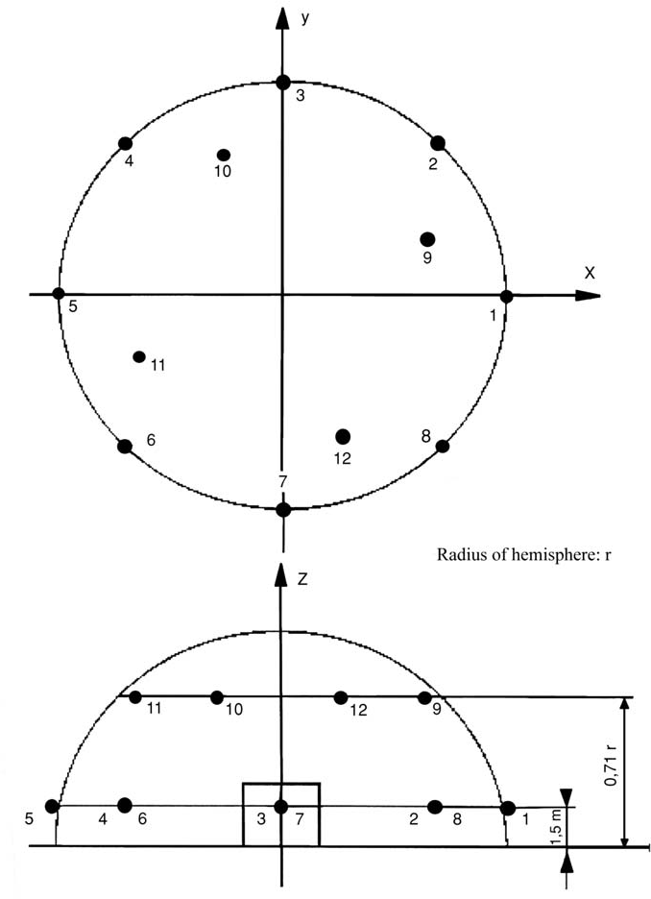

PART B

NOISE TEST CODES FOR SPECIFIC EQUIPMENT

- EQUIPMENT THAT IS TESTED FREE OF LOAD
Test area
Reflecting surface of concrete or non-porous asphalt

Environmental correction K_{2A} K_{2A} = 0
Measurement surface/number of microphone positions/measuring distance
  - If the largest dimension of the reference parallelepiped does not exceed 8 m:

hemisphere/six microphone positions according to Part A item 5/ac­ cording to Part A item 5
  - If the largest dimension of the reference parallelepiped exceeds 8 m: parallelepiped according to ISO 3744:1995 with measurement distance
d = 1 m

Test free of load:
The noise tests shall be carried out according to Part A item 2.2

Period(s) of observation/determination of resulting sound power level if more than one operating condition is used
The period of observation shall at least be 15 seconds or at least 3 operation cycles of the machine.

AERIAL ACCESS PLATFORMS WITH COMBUSTION ENGINE

EN 280-1:2022, Annex M

BRUSH CUTTERS

EN ISO 22868:2021

BUILDERS' HOISTS FOR THE TRANSPORT OF GOODS
See No 0

The geometrical centre of the engine shall be positioned above the centre of the hemisphere; the lift shall move without load and leave the hemisphere — if necessary — in direction of point 1

BUILDING SITE BAND SAW MACHINES

Measurement surface/number of microphone positions/measuring distance
ISO 7960:1995, Annex J with d = 1 m

Test under load
Corresponding to ISO 7960:1995, Annex J (point J2(b) only)

Period of observation
Corresponding to ISO 7960:1995, Annex J

BUILDING SITE CIRCULAR SAW BENCHES

Measurement surface/number of microphone positions/measuring distance
ISO 7960:1995, Annex A, measurement distance d = 1 m

Test under load
ISO 7960:1995, Annex A (point A2(b) only)

Period of observation
ISO 7960:1995, Annex A

- CHAIN SAWS, PORTABLE
- Combustion-energy driven equipment :
EN ISO 22868:2021

- Electric-motor operated equipment :
EN 62841-4-1:2020

COMBINED HIGH PRESSURE FLUSHERS AND SUCTION VEHICLES
If it is possible to operate both items of equipment simultaneously, this shall be done according to Nos 26 and 52. If not, they shall be measured separately and the higher values are to be stated

COMPACTION MACHINES
- Vibratory plates and vibratory rammers
EN 500-4: 2011, clause 5.10.1
- Rollers
EN 500-4: 2011, clause 5.10.2

COMPRESSORS
EN ISO 2151:2008

Period of observation
The period of observation shall be at least 15 seconds

CONCRETE-BREAKERS AND PICKS, HAND-HELD EN 60745-2-6:2010

CONCRETE OR MORTAR MIXERS EN 12151:2007, Annex C

CONSTRUCTION WINCHES
EN 14492-2:2019, Annex M

CONVEYING AND SPRAYING MACHINES FOR CONCRETE AND MORTAR
EN 12001:2012, Annex C

CONVEYOR BELTS
See No 0
The geometrical centre of the engine shall be positioned above the centre of the hemisphere; the belt shall move without load and leave the hemisphere, if necessary, in the direction of point 1

COOLING EQUIPMENT ON VEHICLES

EN 12102-1:2017
Test under load
The cooling equipment shall be installed in a real or simulated cargo space and be tested in a stationary position where the height of the cooling equipment shall be representative of the intended installation requirements according to the instructions supplied to the purchaser. The power source of the cooling equipment shall operate at the rate that causes the maximum speed of the cooling compressor and the fan specified in the instructions. If the cooling equipment is intended to be powered by the driving engine of the vehicle the engine shall not be used during the test and the cooling equipment shall be connected to a suitable electrical power source. Removable tractor units shall be removed during the test
Cooling equipment installed in cargo-space refrigeration units which have a choice of different power sources shall be tested separately for each power source. The test result reported shall as a minimum reflect the mode of operation which leads to the maximum noise output
Period of observation
The period of observation shall at least be 15 seconds

DOZERS

ISO 6395:2008, Annex C

Crawler dozers shall be tested on the test site corresponding to point 6.3.3 of ISO 6395:2008

DRILL RIGS
EN 16228-1:2014+A1:2021, Annex B together with the applicable additional requirements of EN 16228-2:2014+A1:2021, Annex A

DUMPERS

ISO 6395:2008, Annex F

Test under load
Equivalent ISO 6395:2008, Annex F, with the following amendment: F.4.3, second paragraph is replaced by:
‘The engine shall be operated at its maximum governed speed (high idle). The transmission control shall be set to neutral. Bring the bucket to the tipped position (emptying) up to about 75 % of its maximum movement and return it to its travelling position three times. This sequence of events is considered to be a single cycle for the stationary hydraulic mode.

If no engine power is used to tip the bucket, the engine shall be operated at idling speed with the transmission in neutral. The measurement shall be performed without tipping the bucket, the period of observation shall be 15 seconds.’

EQUIPMENT FOR LOADING AND UNLOADING TANKS OR SILOS ON TRUCKS
See No 9 for compressors or vacuum pumps
See No 56 for liquid pumps

EXCAVATORS

ISO 6395:2008, Annex B

- EXCAVATORS-LOADERS

ISO 6395:2008, Annex D

GLASS RECYCLING CONTAINERS

For the purpose of this noise test code the single-event sound pressure level L_{pls} as defined in EN ISO 3744:2010 point 3.4 is used in measuring the sound pressure level at the microphone positions

Environmental correction K_{2A}
Measurement in the open air
K_{2A}=0
Measurements indoors
The value of the constant K_{2A}, determined in accordance with Annex A to EN ISO 3744:2010, shall be ≤ 2,0 dB in which case K_{2A} shall be disregarded

Operating conditions during test
The noise measurement shall be carried out during a complete cycle beginning with the empty container and completed when 120 bottles have been thrown into the container

The glass bottles are defined as follows:

— capacity: 75 cl

— mass: 370 ± 30 g.

The testing operator holds each bottle by its neck and with its bottom towards the filling aperture and then he pushes it gently inside through the filling aperture in the direction of the centre of the container, avoiding if possible the bottle hitting against the walls. Only one filling aperture is used for throwing the bottles and it is the one nearest to microphone position 12

Period(s) of observation/determination of resulting sound power level if more than one operating condition is used
The A-weighted single-event sound pressure level is preferably simulta­ neously measured at the six microphone positions for each bottle thrown into the container

The A-weighted single-event sound power level averaged over the measurement surface is calculated according to EN ISO 3744:2010, point 8.2.2

The A-weighted single-event sound pressure level averaged over all 120 throwings of bottles is calculated as the logarithmic mean of the A- weighted single-event sound pressure levels averaged over the measurement surface

GRADERS

ISO 6395:2008, Annex G

GRASS TRIMMERS/GRASS EDGE TRIMMERS
See No 2

HEDGE TRIMMERS

a) combustion-energy driven equipment:
EN ISO 22868:2021
b) electric-motor operated equipment:
EN IEC 62841-4-2:2019

- HIGH PRESSURE FLUSHERS Basic noise emission standard EN ISO 3744:2010

Operating conditions during test
Test under load
The high pressure flusher shall be tested in a stationary position. The engine and auxiliary units operate at the speed provided by the manufacturer for the operation of the working equipment; the high pressure pump(s) is (are) operating at its (their) maximum speed and operating pressure provided by the manufacturer. Using an adapted nozzle the pressure reduction valve shall be just on the point of reacting. The flow noise of the nozzle shall not have any influence on the results of the measurements

Period of observation
The period of observation shall at least be 30 seconds

HIGH PRESSURE WATER JET MACHINES
- Equipment with pressure rating ≤ 35 MPa:
EN 60335-2-79:2012, Annex CC
- Equipment with pressure rating > 35 MPa:
EN 1829-1:2010, Annex A

- HYDRAULIC HAMMERS

Measurement surface/number of microphone positions/measuring distance
Hemisphere/six microphone positions according to Part A, item 5/r = 10 m

Operating conditions during tests
Mounting of the equipment
For the test the hammer is attached to a carrier and a special test block structure shall be used. Figure 28.1 gives the characteristics of this structure and Figure 28.2 shows the position of the carrier

Carrier
The carrier for the test hammer shall meet the requirements of the test hammer's technical specifications especially in weight range, hydraulic output power, supply oil flow and return line back pressure

Mounting
Mechanical mounting as well as connections (hoses, pipes …) must correspond to specifications given in the hammer's technical data. All significant noise caused by pipes and various mechanical components needed for installation, ought to be eliminated. All component connections have to be well tightened

H a m m e r s t a b i l i t y a n d s t a t i c h o l d f o r c e
The hammer shall be firmly held down by the carrier in order to give the same stability as that existing under normal operating conditions. The hammer must be operated in an upright position

Tool
A blunt tool shall be used in the measurements. The length of the tool must meet the requirements given in Figure 28.1 (test block)

Test under load
Hydraulic input power and oil flow
Operating conditions of the hydraulic hammer shall be appropriately adjusted, measured and reported along with the corresponding technical specification values. The hammer under test must be used in such way that 90 % or more of the maximum hydraulic input power and oil flow of the hammer can be reached
Care shall be taken that the total uncertainty of the measurement chains of p_{s} and Q is kept within ± 5 %. This assures the hydraulic input power deter­ mination within ± 10 % accuracy. Assuming linear correlation between hydraulic input power and emitted sound power this would mean variation of less than ± 0,4 dB in the determination of the sound power level
Adjustable components having effect on the hammer power
Pre-settings of all accumulators, pressure central valves and other possible adjustable components must meet the values given in technical data. If more than one fixed impact rate is optional, measurements have to be made using all settings. Minimum and maximum values are presented
Quantities to be measured

p_{s} The mean value of the hydraulic supply fine pressure during the hammer's operation including at least 10 blows
Q The mean value of the breaker inlet oil flow measured simultan­ eously with p_{s}
T The oil temperature must lie between + 40/ + 60 °C during measurements. The temperature of the hydraulic breaker body must have been stabilised to normal operating temperature before starting the measurements
P_{a} The prefill gas pressures of all accumulators must be measured in static situation (breaker not operating) at stable ambient temperature of + 15/ + 25 °C. The measured ambient temperature shall be recorded with the measured accumulator prefill gas pressure
Parameters to be evaluated from the measured operating parameters: P_{IN} Hydraulic input power of the breaker P_{IN} = p_{s} · Q
H y d r a u l i c s u p p l y l i n e p r e s s u r e m e a s u r e m e n t , p _{s}
- p_{s} must be measured as close to the breaker IN-port as possible
- p_{s} shall be measured with a pressure gauge (minimum diameter: 100 mm; accuracy class ± 1,0 % FSO)
Breaker inlet oil flow, Q
- Q must be measured from the supply pressure line as close to the breaker IN-port as possible
- Q must be measured with an electric flowmeter (accuracy class ± 2,5 % of the flow reading)
Measuring point of the oil temperature, T
- T must be measured from the oil tank of the carrier or from the hydraulic line connected to hammer. Measuring point shall be specified in the report
- accuracy of the temperature reading must lie within ± 2 °C of the actual value
Period of observation/determination of resulting sound power level
The period of observation shall be at least 15 seconds
The measurements are repeated three times, or more if necessary. The final result is calculated as the arithmetic mean of the two highest values that do not differ by more than 1dB
Figure 28.1
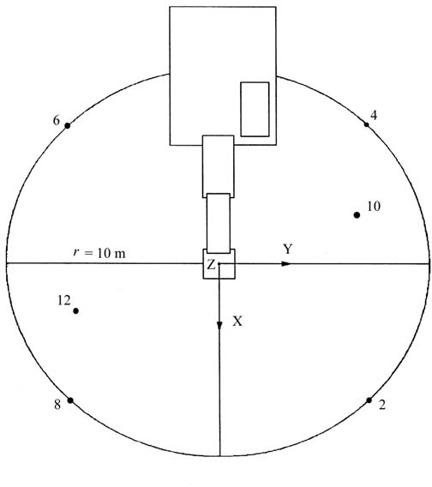

Figure 28.2

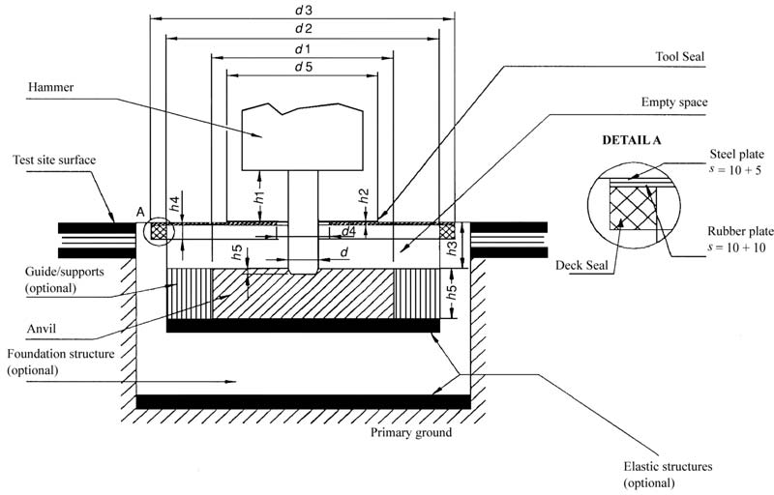

D e f i n i t i o n s

d Tool diameter (mm)
d₁ Anvil diameter, 1 200 ± 100 mm
d₂ Inner diameter of the anvil support structure, ≤ 1 800 mm
d₃ Diameter of the test block deck, ≤ 2 200 mm
d₄ Diameter of the tool opening in the deck, ≤ 350 mm
d₅ Diameter of the tool seal, ≤ 1 000 mm
h₁ Visible tool length between the lowest part of the housing and tool seal upper surface (mm), h₁ = d ± d/2
h₂ Tool seal thickness above the deck, ≤ 20 mm (if the tool seal is located below the deck, its thickness is not limited; it may be made of foam rubber)
h₃ Distance between deck upper surface and anvil upper surface, 250 ± 50 mm
h₄ Isolating foam rubber deck seal thickness, ≤ 30 mm
h₅ Anvil thickness, 350 ± 50 mm
h₆ Tool penetration, ≤ 50 mm
If the quadratic shape of the test block structure is used, the maximum length dimension equals 0,89 × corresponding diameter

The empty space between the deck and the anvil can be filled with elastic foam rubber or other absorption material, density < 220 kg/m³

- HYDRAULIC POWER PACKS

Mounting of equipment
The hydraulic power pack shall be installed on the reflecting plane; skid- mounted hydraulic power packs shall be placed on a support 0,40 m high, unless otherwise required by the manufacturer's conditions of installation

Test under load
During testing, no tools shall be coupled to the hydraulic power pack

The hydraulic power pack shall be brought to its steady state within the range specified by the manufacturer. It shall operate at its nominal speed and its nominal pressure. The nominal speed and pressure are those appearing in the instructions supplied to the purchaser

Period of observation
The period of observation shall at least be 15 seconds

JOINT CUTTERS

EN 13862:2021, Annex B

LANDFILL COMPACTORS
ISO 6395:2008, Annex H

LAWNMOWERS

a) combustion-energy driven equipment:
EN ISO 5395-1:2013, Annex F
EN ISO 5395-1:2013/A1:2018
b) electric-motor operated equipment

EN IEC 62841-4-3:2021

LAWN TRIMMERS/LAWN EDGE TRIMMERS
EN 50636-2-91:2014, Annex CC

LEAF BLOWERS

a) combustion-energy driven equipment:
EN 15503:2009+A2:2015, Annex A

b) electric-motor operated equipment:
EN 50636-2-100:2014, Annex CC

LEAF COLLECTORS
See No. 34

LIFT TRUCKS

EN 12053:2001+A1:2008

LOADERS

ISO 6395:2008, Annex D

Crawler loaders shall be tested on the test site corresponding to point 6.3.3 of ISO 6395:2008

MOBILE CRANES

EN 13000:2010+A1:2014

MOBILE WASTE CONTAINERS

Test area
- Reflecting surface of concrete or non-porous asphalt

- Laboratory room which provides a free field over a reflecting plane

Environmental correction K_{2A}
M e a s u r e m e n t i n t h e o p e n a i r
K_{2A} = 0

M e a s u r e m e n t i n d o o r s
The value of the constant K_{2A}, determined in accordance with Annex A to EN ISO 3744:1995, shall be ≤ 2,0 dB, in which case K_{2A} shall be disregarded

Measurement surface/number of microphone positions/measuring distance
Hemisphere/six microphone positions according to Part A item 5/r = 3 m

Operating conditions during test
All the measurements shall be carried out with an empty container

Test No 1: Free shutting down of the lid along the container body
To minimise his influence on the measurements, the operator shall stand at the back side of the container (hinge side). The lid shall be released by its middle, to prevent warping during its fall

The measurement is carried out during the following cycle, repeated 20 times:

- initially, the lid is raised vertically

- the lid is released forward, if possible without giving an impulse, with the operator at the back of the container, unmoving until the lid is shut

- after complete shutting, the lid is raised to its initial position

Note: If necessary the operator can move temporarily to raise the lid.
Test No 2: Complete opening of the lid
To minimise his influence on the measurements, the operator shall stand at the back side of the container (hinge side) for the four-wheel containers, or on the right side of the container (between microphone position 10 and microphone position 12) for the two-wheel containers. The lid shall be released by its middle or as near as possible to its middle

To prevent any moving of the container, wheels shall be locked during the test. For the two-wheel containers, and to prevent any bounce of the container, the operator can maintain it by placing his hand on the top rim.
The measurement is carried out during the following cycle:

- initially, the lid is opened horizontally

- the lid is released without giving an impulse

- after complete opening, and before a possible rebond, the lid is raised to its initial position

Test No 3: Rolling of the container over an artificial irregular track
For this test, an artificial test track, simulating irregular ground is used. This test track consists of two parallel strips of steel mesh (6 m long and 400 mm wide), fastened in the reflecting plane approximately every 20 cm. The distance between the two strips is adapted according to the type of container, in order to allow the wheels to roll all over the whole length of the track. The mounting conditions shall ensure a flat surface. If necessary, the track is fastened on the ground with resilient material to avoid emission of parasitic noise

Note: Every strip can be composed of several 400 mm wide elements fitted together
An example of adequate track is given in Figures 39.1 and 39.2 The operator is situated at the lid hinge side
The measurement is carried out while the operator draws the container along the artificial track, with a constant speed of approximately 1 m/s, between points A and B (4,24 m distance — see Figure 39.3) when the wheel axle, for a 2-wheel container, or the first wheel axle for a 4-wheel container, reaches point A or point B. This procedure is repeated three times in each direction

During the test, for a 2-wheel container, the angle between the container and the track shall be 45°. For a 4-wheel container, the operator shall ensure an appropriate contact of all the wheels with the track.

Period(s) of observation/determination of resulting sound power level if more than one operating condition is used
Test Nos 1 and 2: Free shutting down of the lid along the container body and complete opening of the lid
If possible, the measurements are carried out simultaneously at the six microphone positions. Otherwise, the sound levels measured at each microphone position will be classified in increasing order and the sound power levels are calculated by associating the values at each microphone position according to their row

The A-weighted single-event sound pressure level is measured for each of the 20 shuttings and the 20 openings of the lid at each measurement point. The sound power levels L_{WAshutting} and L_{WAopening} are calculated from the quadratic mean of the five highest values among those obtained

Test No 3: Rolling the container over an artificial irregular track
The period of observation T shall be equal to the duration necessary to cover the distance between point A and point B on the track.

The sound power level L_{WArolling} is equal to the mean of six values differing by less than 2 dB. If this criterion is not fulfilled with six measurements, the cycle is repeated as far as necessary

The resulting sound power level is calculated by:

L WA ¼ 10 log1ð100,1 LWAshutting þ 100,1 LWAopening þ 100,1 LWArolling Þ
3
Figure 39.1

Drawing of the rolling track
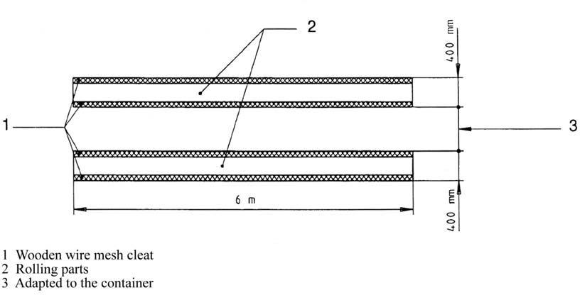

Figure 39.2

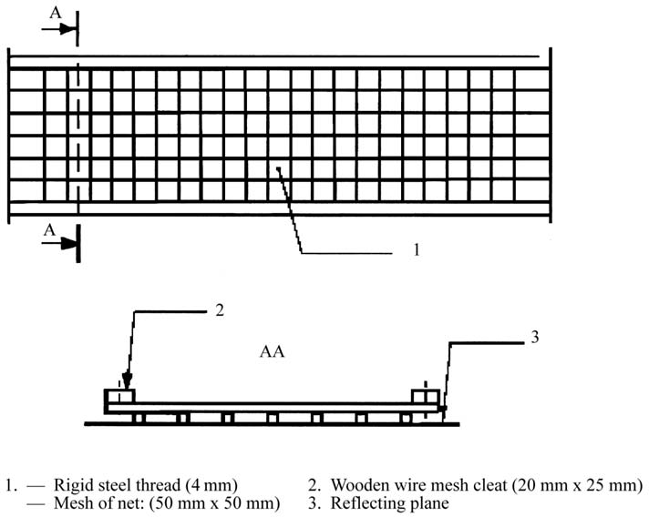
Detail of construction and mounting of the rolling track

Figure 39.3

Measurement distance

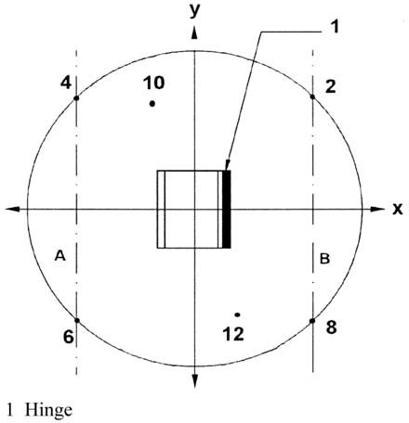

- MOTOR HOES
See No 32

PAVER-FINISHERS

EN 500-6:2006+A1:2008

PILING EQUIPMENT

EN 16228-1:2014+A1:2021, Annex B together with the applicable additional requirements of EN 16228-4:2014+A1:2021, Annex A and EN 16228-7:2014+A1:2021, Annex A.

PIPELAYERS
ISO 6393:2008

PISTE CATERPILLARS
ISO 6393:2008, operating conditions for tractor-dozers (Annex ?)

- POWER GENERATORS

EN ISO 8528-10:2022

POWER SWEEPERS

Road sweepers: EN 17106-1:2021, Annex B
Other power sweepers for use out-doors: EN 60335-2-72:2012, Annex DD

REFUSE COLLECTION VEHICLES

EN 1501-4:2007

- ROAD MILLING MACHINES

EN 500-2:2006+A1:2008, Annex A

SCARIFIERS

a) combustion-energy driven equiopment:
EN 13684:2018, Annex C
b) electric-motor operated equipment:
EN 50636-2-92:2014 , Annex DD

- SHREDDERS/CHIPPERS

Shredders/chippers
a) combustion-energy driven equipment
EN 13683:2003+A2:2011, Annex F
b) electric-motor operated
EN 50434:2014, Annex FF

Wood chippers
EN 13525:2020, Annex B

SNOW REMOVING MACHINES WITH ROTATING TOOLS See No. 44

SUCTION VEHICLES

Test under load
The suction vehicle shall be tested in a stationary position. The engine and auxiliary units operate at the speed provided by the manufacturer for the operation of the working equipment; the vacuum pump(s) is (are) operating at its (their) maximum speed provided by the manufacturer. The suction equipment is operated in such a way that the internal pressure is equal to atmospheric pressure (0 % vacuum). The flow noise of the suction nozzle shall not have any influence on the results of the measurements
Period of observation
The period of observation shall at least be 15 seconds

TOWER CRANES

EN 14439:2006+A2:2009, Annex E

- TRENCHERS
ISO 6393:2008

TRUCK MIXERS

EN 12609:2021, Annex B

WATER PUMP UNITS

EN ISO 20361:2019
EN ISO 20361:2019/A11:2020

- WELDING GENERATORS

EN ISO 8528-10:2008

Net power means the power in ‘EC kW’ obtained on the test bench at the end of the crankshaft, or its equivalent, measured in accordance with the EC method of measuring the power of internal combustion engines for road vehicles, except that the power of the engine cooling fan is excluded. The measurement of engine power in reciprocating internal combustion engines shall follow ISO 14396:2002. In the case of earth moving machinery the measurement of engine net power shall follow ISO 9249:2007.

